**Project Design Phase-II**

**Technology Stack (Architecture & Stack)**

|  |  |
| --- | --- |
| Date | 03 October 2022 |
| Team ID | PNT2022TMID07105 |
| Project Name | Project - Real-Time communication system powered by AI for specially abled |
| Maximum Marks | 4 Marks |

**Technical Architecture:**

The Deliverable shall include the architectural diagram as below and the information as per the table1 & table 2

**Example: Real-Time communication system powered by AI for specially abled**

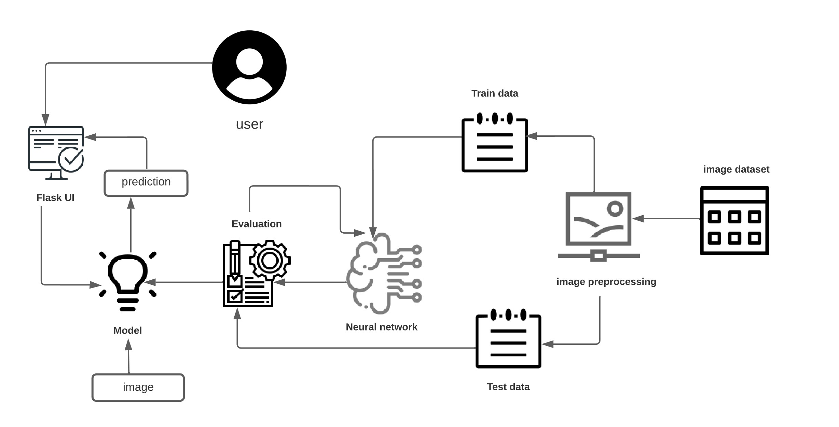

**Table-1 : Components & Technologies:**

|  |  |  |  |
| --- | --- | --- | --- |
| **S.No** | **Component** | **Description** | **Technology** |
| 1. | User Interface | How user interacts with application i.e, Web UI, Mobile App, Chatbot etc. | HTML, CSS, JavaScript / Angular Js / React Js/ flask UI etc. |
| 2. | Application Logic-1 | Captures the sign  Camera detects the sign | Face and hand detector is used. |
| 3. | Application Logic-2 | Image is captured clearly | Gray scale image . |
| 4. | Application Logic-3 | Convert text to speech | Speech assistant is implemented. |
| 5. | Database | Data Type- Binary large object is used, Configurations-mysql/my.cnf, etc. | MySQL. |
| 6. | File Storage | File storage requirements – jpeg,png,psd | Local Filesystem |
| . | Machine Learning Model | Algorithm Is fed to the system | Object Recognition Model, etc. |

**Table-2: Application Characteristics:**

|  |  |  |  |
| --- | --- | --- | --- |
| **S.No** | **Characteristics** | **Description** | **Technology** |
| 1. | Open-Source Frameworks | Image capturing, speech assistant,sign language detection | Pipe framework |
| 2. | Scalable Architecture | scalability of architecture (3 – tier depth-many layers,width-neurons,resolution-learn complex features | CNN(Convolution Neural Network) |
| 4. | Availability | Hand signs,text,images | CNN,speech assistant,machine learning |